Jack McCall

Endless

Design Document

Table of Contents

1 Document History 2

2 Project Overview 3

2.1 Elevator Pitch 3

2.2 Summary 3

3 Gameplay 3

3.1 Artificial Intelligence 3

# Document History

|  |  |  |
| --- | --- | --- |
| v.0.1 | Preliminary document created | 28/6/2017 |
|  |  |  |

# Project Overview

## Elevator Pitch

Endless is a top-down infinite shooter where the player must defend the base against endless waves of enemy attacks.

## Summary

# Gameplay

## Artificial Intelligence

AI within the game will use an A-star Distance heuristic to calculate pathfinding for enemies within the game. Enemies will spawn at random locations in the map, wandering, until they get close enough to either the base or the player. At which point, they will switch to a ‘seek’ behavior until they get within attack distance.

## Movement System

## Agents

### Player

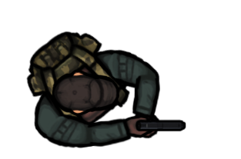

##### Behaviours

The player will be able to earn money by killing enemies, which can be used to purchase base/weapon upgrades or new weapons.

### Enemies

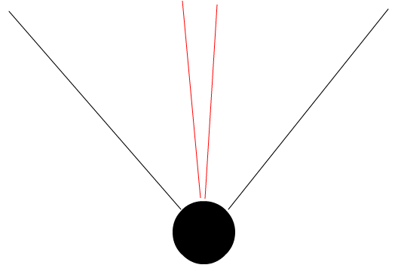

The black arc describes the ‘visible’ range of an entity – what it can ‘see’. The red arc depicts its current line of sight. If an entity is within visible range, but not in line of sight, the enemy will turn to completely face the targeted entity (entity falls within line of sight arc) before moving forward or attacking.

#### Behaviours

**Wander:** Will pick a random location to walk towards. Random chance that it will pick a new location each interval or keep current target.

**Seek:** Will move towards the targeted entity if within agro range and FOV.

**Flee:** Will retreat away from targeted entity if it is within agro range.

**Attack:** Will perform attacking actions if targeted entity is close enough.

#### Gargant



##### Unique Behaviours

**Attack:** Creature performs a range “Spit” attack with acid.

#### Bandit

##### Unique Behaviours

**Attack:** Creature performs a melee attack.